1. Arrange in the increasing order : f1(n)=2n ,f2(n)= n3/2  ,f3(n)=nlog2n ,f4(n)= n log2n

Ans: f3,f2,f4,f1

1. Find an average no of comparisons performed by merge sort algorithm in merging 2 sorted lists of length 2.

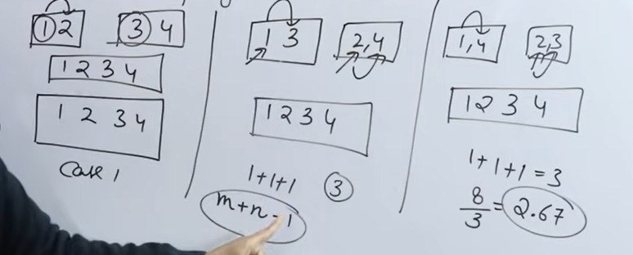

Ans: 2.67

1. What is time complexity of fun()?

**int** fun(**int** n)

{

**int** count = 0;

**for** (**int** i = n; i > 0; i /= 2)

**for** (**int** j = 0; j < i; j++)

            count += 1;

**return** count;

}

Ans: O(n)

**Explanation:**

For an input integer n, the innermost statement of fun() is executed following times. n + n/2 + n/4 + … 1

So time complexity T(n) can be written as T(n) = O(n + n/2 + n/4 + … 1) = O(n)

The value of count is also n + n/2 + n/4 + .. + 1

1. What is the value of following recurrence.

T(n) = 5T(n/5) + sqrt(n)  
T(1) = 1,  
T(0) = 0

Ans: Theta(n) Master theorem case 1

1. Which of the following is not O(n2)?

15 * n2  , n1.98 , n3/sqrt(n) , 20 * n2

Ans: n3/sqrt(n)

**Explanation:**

The order of growth of option c is n2.5 which is higher than n2.

1. Consider the weights and values of items listed below. Note that there is only one unit of each item.

| **Item number** | **Weight (in Kgs)** | **Value (in Rupees)** |
| --- | --- | --- |
| **1** | **10** | **60** |
| **2** | **7** | **28** |
| **3** | **4** | **20** |
| **4** | **2** | **24** |

The task is to pick a subset of these items such that their total weight is no more than 11 kgs and their total value is maximized. Moreover, no item may be split. The total value of items picked by an optimal algorithm is denoted by Vopt. A greedy algorithm sorts the items by their value-to-weight ratios in descending order and packs them greedily, starting from the first item in the ordered list. The total value of items picked by the greedy algorithm is denoted by Vgreedy.

Find the value of Vopt − Vgreedy .

Ans: 16

1. **Solve the following instance of “job scheduling with deadlines” problem : n = 7, profits (p1, p2, p3, p4, p5, p6, p7) = (3, 5, 20, 18, 1, 6, 30) and deadlines (d1,  d2, d3, d4, d5, d6, d7) = (1, 3, 4, 3, 2, 1, 2). Schedule the jobs in such a way to get maximum profit.**

**Ans:** with the greedy approach, we will be able to schedule four jobs {J7, J3, J4, J6}, which give a profit of (30 + 20 + 18 + 6) = 74 units.

|  |
| --- |
|  |  |
|  |  |
|  |  |